**S7.2 Write a program to prompt the user for a file name, and then read through the file and look for lines of the form:**

X-DSPAM-Confidence:  0.8475

**When you encounter a line that starts with "X-DSPAM-Confidence:" pull apart the line to extract the floating point number on the line. Count these lines and the compute the total of the spam confidence values from these lines. When you reach the end of the file, print out the average spam confidence.**

Enter the file name: mbox.txt

Average spam confidence: 0.894128046745

Enter the file name: mbox-short.txt

Average spam confidence: 0.750718518519

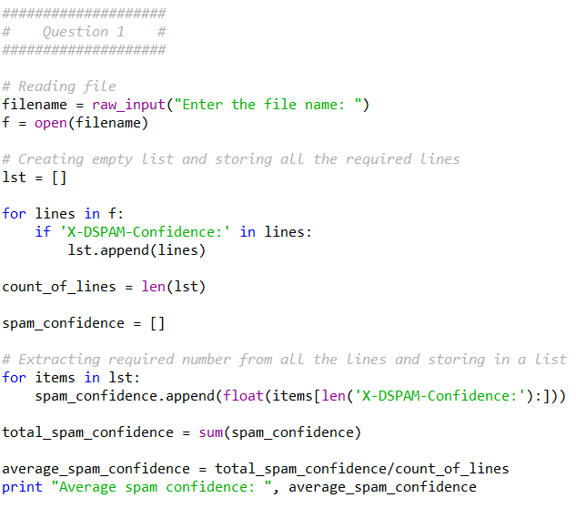

**S8.5 Write a program to read through the mail box data and when you find line that starts with "From", split the line into words using the split function. Parse the From line and print out the second word for each From line and also count the number of From (not From:) lines and print out a count at the end.**

From stephen.marquard@uct.ac.za Sat Jan 5 09:14:16 2008

**This is a sample good output with a few lines removed:**

python fromcount.py

Enter a file name: mbox-short.txt

stephen.marquard@uct.ac.za

louis@media.berkeley.edu

zqian@umich.edu

[...some output removed...]

ray@media.berkeley.edu

cwen@iupui.edu

cwen@iupui.edu

cwen@iupui.edu

There were 27 lines in the file with From as the first word

**Do not use the regexp module.**

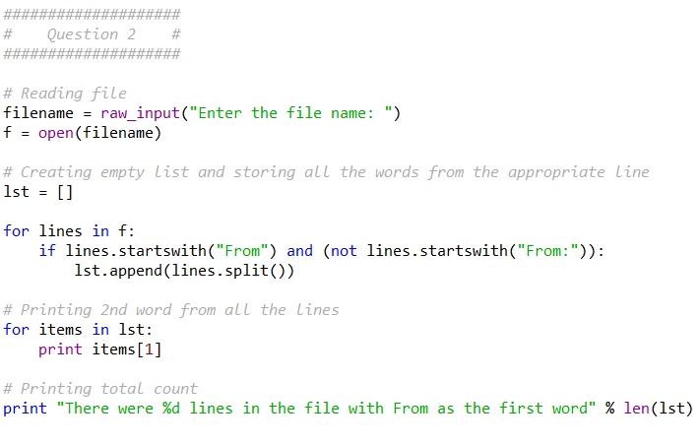

**S9.3-4 Write a program to read through a mail log, and build a histogram using a dictionary to count how many messages have come from each email address and print the dictionary.**

Enter file name: mbox-short.txt

{'gopal.ramasammycook@gmail.com': 1, 'louis@media.berkeley.edu': 3,

'cwen@iupui.edu': 5, 'antranig@caret.cam.ac.uk': 1,

'rjlowe@iupui.edu': 2, 'gsilver@umich.edu': 3,

'david.horwitz@uct.ac.za': 4, 'wagnermr@iupui.edu': 1,

'zqian@umich.edu': 4, 'stephen.marquard@uct.ac.za': 2,

'ray@media.berkeley.edu': 1}

**Now add code to the above program to determine who has the most messages in the file. Specifically, after all the data has been read and the dictionary has been created, look through the dictionary using a maximum loop) to find who has the most messages and print how many messages the person has.**

Enter a file name: mbox-short.txt

cwen@iupui.edu 5

Enter a file name: mbox.txt

zqian@umich.edu 195

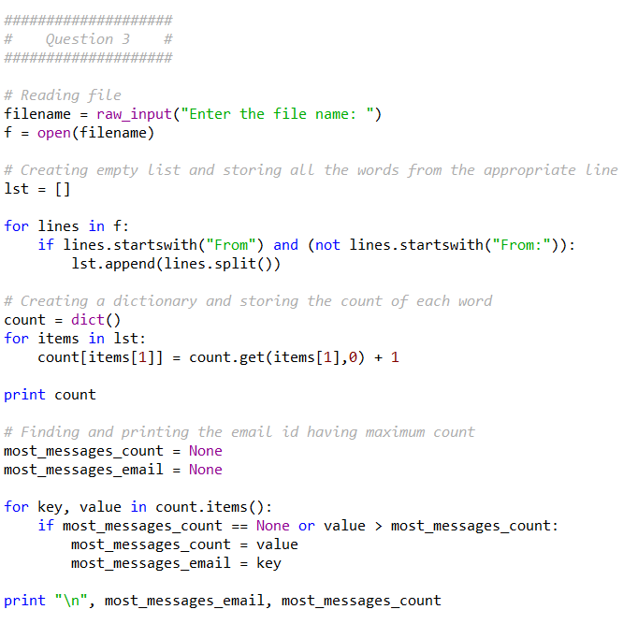

### S10.2 Write a program to count the distribution of the hour of the day for messages . Pull the hour from the "From" line by finding the time string and then splitting that string into parts using the colon character. Once you have accumulated the counts for each hour, print out the counts, one per line, sorted by hour as shown below. Do not use the regexp module.

### Sample Execution:

python timeofday.py

Enter a file name: mbox-short.txt

04 3

06 1

07 1

09 2

10 3

11 6

14 1

15 2

16 4

17 2

18 1

19 1

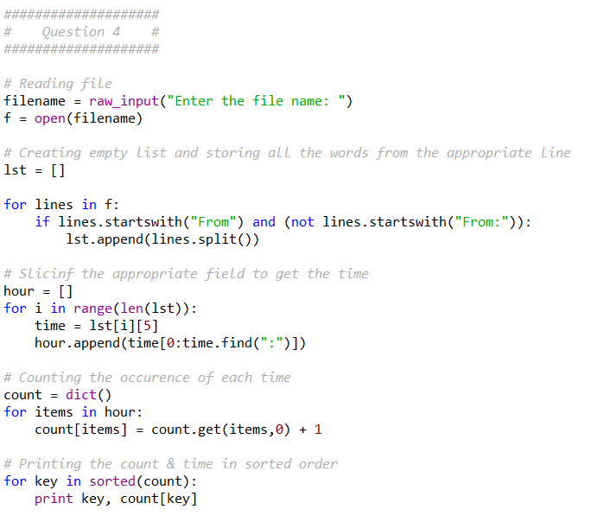

**S11.2 Write a program to look for lines of the form**

New Revision: 39772

**Extract the number from each of the lines using a regular expression and the findall() method. Compute the average of the numbers and print out the average.**

Enter file:mbox.txt

38549.7949721

Enter file:mbox-short.txt

39756.9259259

